

Ellucian Degree Works
JD Student Guide

Ellucian Degree Works - Introduction
- What is Ellucian Degree Works?
Ellucian Degree Works is a web-based tool to help students and advisors monitor progress toward degree completion. Degree Works lists the courses you have already completed and courses for which you are currently registered, along with the courses you still need to take to graduate and formats it all into an easy-to-read audit.

Degree Works is not meant to replace in-person advising. Your academic advisor will continue to assist you with course selection and to advise you on JD program requirements.

- What is an Audit?
A Degree Works audit is a review of past, current and planned coursework that provides information on completed and outstanding requirements necessary to complete your JD program requirements.
The audit is divided into blocks such as JD Juris Doctor, JD Required Courses, Rule of 65, ABA Experiential Requirement (Evening Students Only), Cardin Day Requirement (Day Students Only), and In-progress. Most blocks work like a checklist with boxes that are automatically checked when a requirement is met. Others simply provide information in list format.

Degree Works – Getting Started
- How do I access Degree Works?
You can access Degree Works by visiting https://degreeworks.umaryland.edu.

Degree Works – What am I looking at?
- Worksheets
Under Worksheets you will see the following:
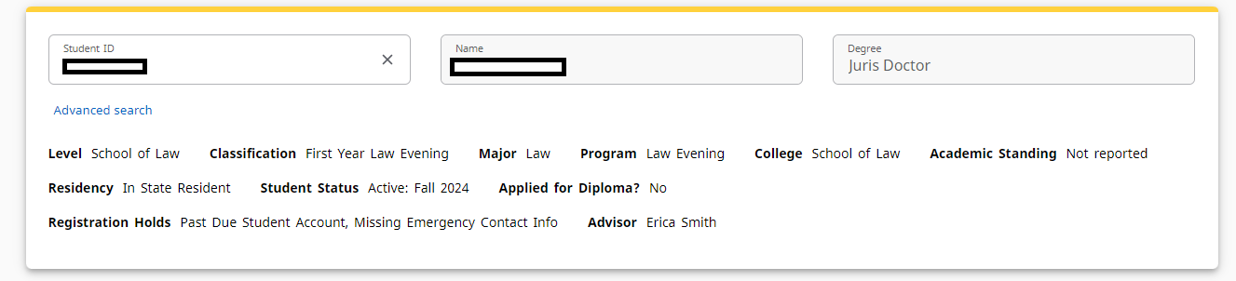
Evening Student Example

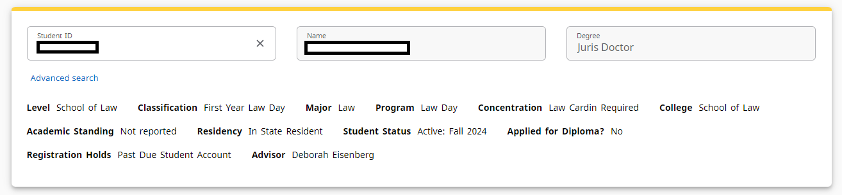
Day Student Example
Please pay attention to the following:
Applied for Diploma?
If you believe you are eligible to graduate, you must submit a Graduation Application in SURFS by the stated deadline for the term you are planning to graduate. If you encounter any issues submitting your graduation application, please send an email to the Office of Registration and Enrollment at registration@law.umaryland.edu. Degree Works will show if you are a JD Degree Candidate or if your Degree has been Awarded.
Registration Holds
All Holds must be cleared before registration in SURFS can occur. Common Holds include:
- Title IX Compliance – Please call 410-706-2281
- Student Health – Please call 667-214-1883
- Past Due Student Account – Please call 410-706-2930
- Missing Emergency Contact Info – Login to SURFS
- Alcohol/Drug Abuse Prevention – Please email rs-studenttrainings@umaryland.edu
Please note that the Law School does not place or remove Holds on student accounts. Holds must be lifted by the department/office that has placed the Holds. As such, you should reach out to the department/office responsible for placing and removing Holds with any questions, comments, or concerns.
Advisor
We recommend that you meet with an Academic Advisor prior to registration each semester. Students are assigned an academic advisor during their first year of law school who can help them navigate the registration process and plan their courses throughout law school. In addition to your assigned advisors, upper-class students and first year students should feel free to reach out to faculty and program staff in various subject areas who can provide students with advice about courses relevant to their interest areas.
Concentration (Day Students Only)
Day students have a Cardin Requirement. This requirement is depicted next to the Concentration field in the Worksheet view.
Audit Blocks
Under Academic you will see the following:
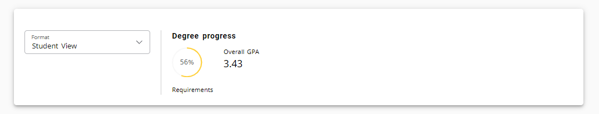
The Student View is the default worksheet format type. It provides general information about your completed and remaining degree requirements, grouped into logical sections or blocks.
The Graduation Checklist View is a less detailed view of the student view.
The Degree Progress Bar is provided to give an idea of how far along you are with your degree requirements. The percentage listed is not intended to indicate how soon you will graduate, rather it counts the number of completed requirements and provides that data as a percentage and in graphic form.


At the bottom of the page, you will find the Legend. Next to each Audit Block, you can see if it is or
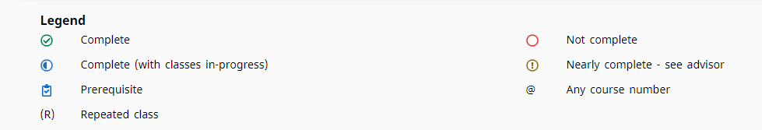
The Legend will be helpful as you view the different Audit Blocks.
- JD Juris Doctor
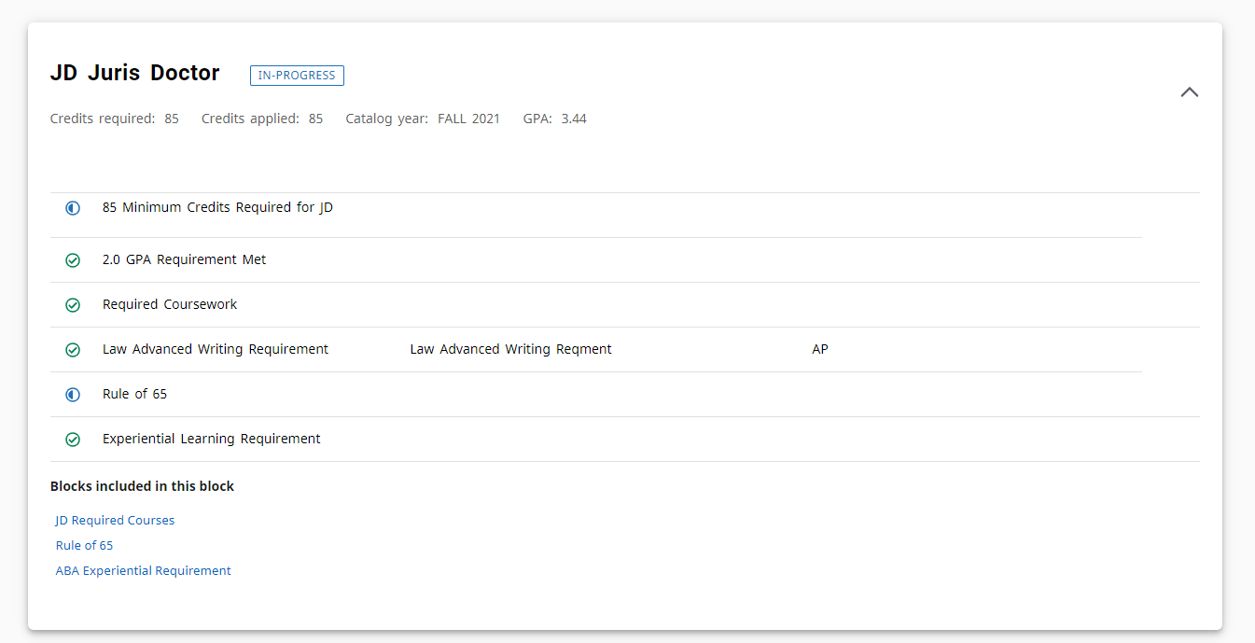
Evening Student Example

This audit block gives you a high-level overview of your progress towards JD degree requirements. Evening Students are required to meet the following criteria, amongst other things:
- Pass courses totaling at least 85 semester hours.
- Have a weighted cumulative average of at least 2.00.
- Complete all JD Required Coursework (see below)
- Satisfy the Advanced Writing Requirement
- Satisfy the Rule of 65 (see below)
- Satisfy the ABA Experiential Requirement (see below)
Please click here for more information about Evening Student Graduation Requirements.
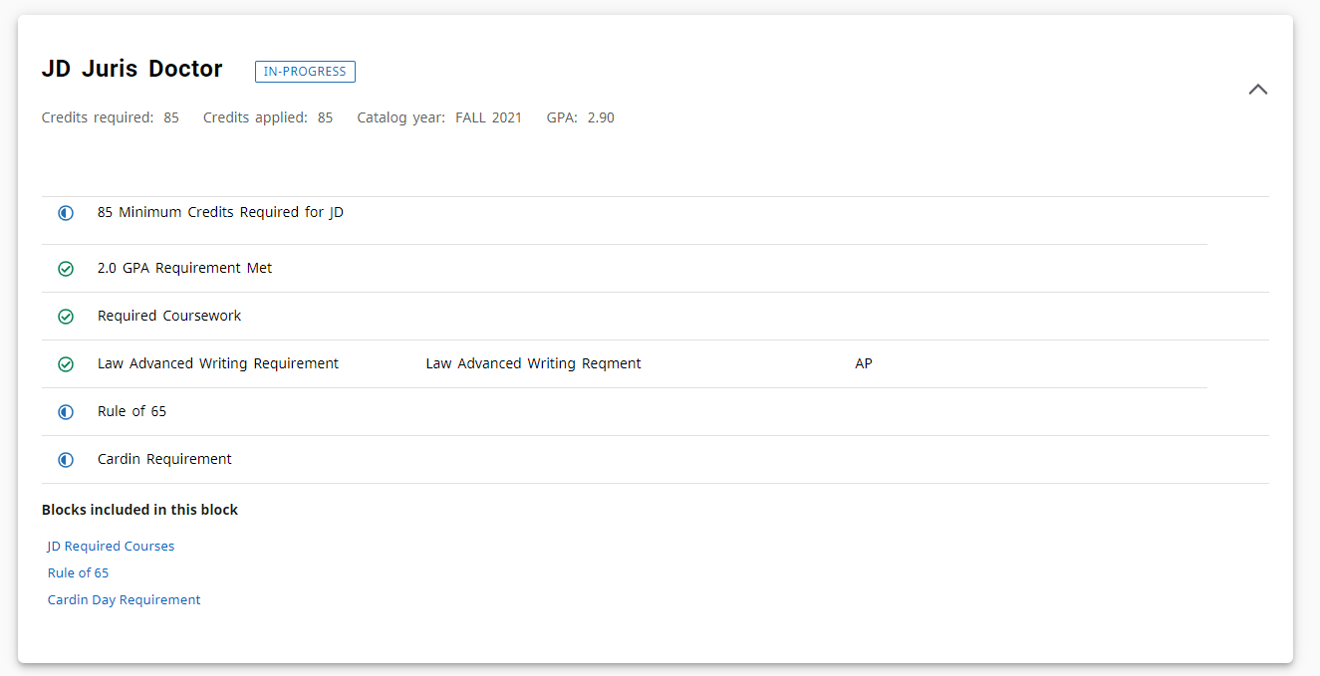
Day Student Example
This audit block gives you a high-level overview of your progress towards JD degree requirements. Day Students are required to meet the following criteria, amongst other things:
- Pass courses totaling at least 85 semester hours.
- Have a weighted cumulative average of at least 2.00.
- Complete all JD Required Coursework (see below)
- Satisfy the Advanced Writing Requirement
- Satisfy the Rule of 65 (see below)
- Satisfy the Cardin Requirement (see below)
Please click here for more information about Day Student Graduation Requirements.

- JD Required Courses
One of the requirements to graduate with your JD is to take and pass the following required courses:
- Civil Procedure
- Contracts
- Torts
- Introduction to Legal Research
- Constitutional Law I
- Property
- Criminal Law
- Advanced Legal Research and Writing
- Constitutional Law II
- Legal Profession
- Lawyering I
- Lawyering II
- Lawyering III (evening students only)
This section will allow you to see which classes you have completed , which classes are complete (with classes in-progress) , and which classes are not complete .
- Rule of 65
One of the requirements to graduate with your JD is to earn at least 65 of the 85 credits required for graduation (see above) in courses other than Externships, Practicums, student publications, elective Moot Court, Trial Team, Alternative Dispute Resolution Team, and graduate level non-law courses.
- ABA Experiential Requirement (Evening Students Only)
All Maryland Carey Law students satisfy the ABA’s six-credit Experiential Requirement as part of their required curriculum. For all students who first matriculate in the Evening Division program, the experiential requirement is satisfied by Lawyering II and Lawyering III. Transfer students must take at least six-credits that satisfy the ABA experiential requirement, which could be a Cardin-eligible course, an externship, or a simulation course.
- Cardin Requirement (Day Students Only)
All Maryland Carey Law students satisfy the ABA’s six-credit Experiential Requirement as part of their required curriculum. For all students who first matriculate as a Day Division student, the experiential requirement is satisfied by Lawyering II plus a clinic or Legal Theory and Practice course that satisfies the Cardin Requirement. Transfer students must take at least six-credits that satisfy the ABA experiential requirement, which could be a Cardin-eligible course, an externship, or a simulation course.

- In-progress
The In-progress block lists the courses for which you are currently registered.

What’s Not Included
- Certificates and Tracks
Unlike in your undergraduate education, you do not need to “major” in a particular subject. Whatever you want to do with your law degree, Maryland Carey Law will prepare you to excel in that field, connect you with our impressive alumni network in your areas of interest, and advise you along the way.
If you want to deepen your study of a particular subject area, Maryland Carey Law offers specialty certificates and tracks in several areas connected with our highly regarded, nationally ranked specialty programs.
The certificates and tracks provide you with a specialized course of study that combines core courses, practical training, professional development opportunities, career counseling, and networking with leading professionals and attorneys in that field. Certificates and tracks provide a field-specific structured curriculum that includes core courses, seminars, and practical experiences.
Certificate programs include:
- Cybersecurity & Crisis Management Law
- Environmental Law & Policy
- Health Law
Tracks include:
- Business Law
- Criminal Law
- Dispute Resolution
- Intellectual Property
Please be advised that you will not be able to audit certificate or track completion via Degree Works. If you are interested in a certificate or track, you should contact the managing director or faculty leaders for the program to learn more about the program requirements.
For more information about certificates and/or tracks, please visit https://www.law.umaryland.edu/academics/certificates--tracks/.

Frequently Asked Questions
Q: What do I do if I have a technical issue while trying to log in or use the Degree Works?
A: If you experience a technical issue while trying to log in or use the Degree Works software, please contact the Helpdesk at help@umaryland.edu.

Q: Can I use Degree Works to register for classes?
A: No. You should register for classes using SURFS.

Q: How current will my information be in Degree Works?
A: The information in Degree Works is refreshed each night. Any changes made today will be seen in Degree Works the next day.

Q: How accurate is the "Degree Progress" bar on my audit?
A: The “Degree Progress” bar is not necessarily exact and is not an official measurement. The percentage is meant as an estimate of your progress towards completion of your degree program.

Q: How do I know what classes I need to take?
A: Your audit will outline courses that can be used to complete each requirement. However, it is recommended that you consult with your academic advisor, prior to registration for the next semester, regarding the courses for which you should register.

Q: I think my audit is incorrect. What should I do?
A: You should reach out to the Office of Registration and Enrollment at registration@law.umaryland.edu. In your email, you should identify what information you believe is wrong and include your student ID number.

Q: If all of the requirement boxes on my audit are checked, does that mean I am graduating?
A: If you believe you are eligible to graduate, you must submit a Graduation Application in SURFS by the stated deadline for the term you are planning to graduate. If you encounter any issues submitting your graduation application, please send an email to the Office of Registration and Enrollment at registration@law.umaryland.edu.

